# Lab: Git and GitHub

# Create a GitHub Developer Profile

## Create a GitHub Profile

Register for a free **developer account at GitHub**: <http://github.com>. Submit your developer profile's URL as output of this homework.

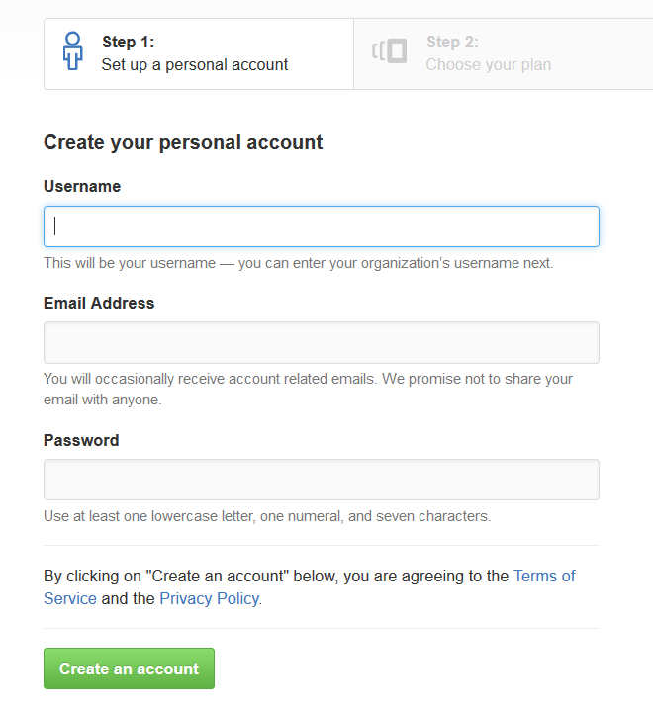

# Creating a Repo + Conflict + Resolve

## Create a GitHub Repository

* New repository form: <https://github.com/new>.
* Choose a name for the repo, e.g. "first-repo". Make sure to   
  "**Initialize this repository with a README**".

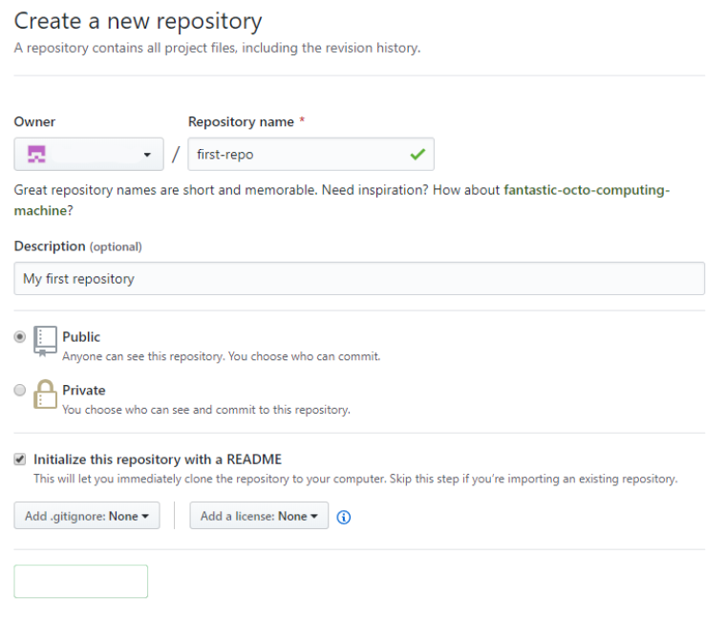

## Clone a Repository Twice

Clone that repository on two different places on your personal device.

* Use Git **clone** for cloning with **TortoiseGit**.
* Go in the desired directory, right click on blank space anywhere in the folder and copy the link of your repository.

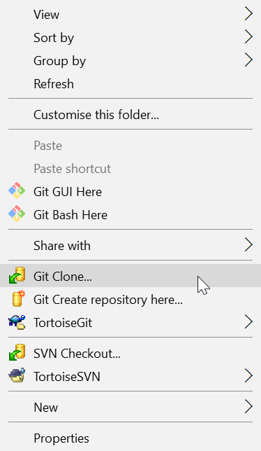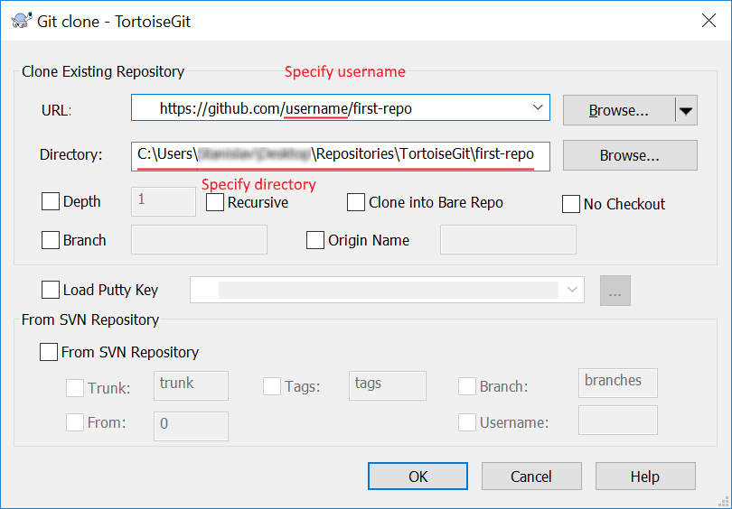

* The result should be something like this:

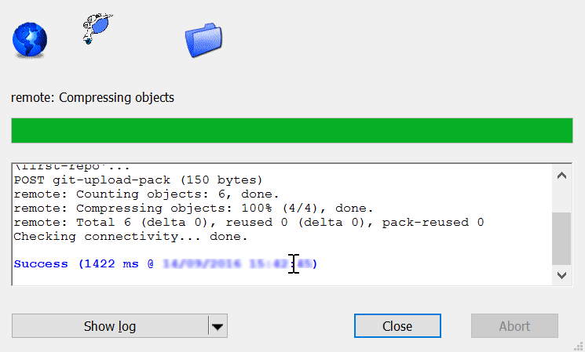

* Use **"git clone"** command for cloning with **GitBash**.
  + Go to the desired **directory**, right click on blank space anywhere in the folder, select "**Git Bash here**" and type **"git clone"** command followed by the link of your repository.

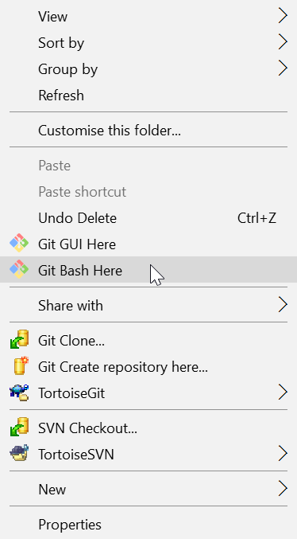

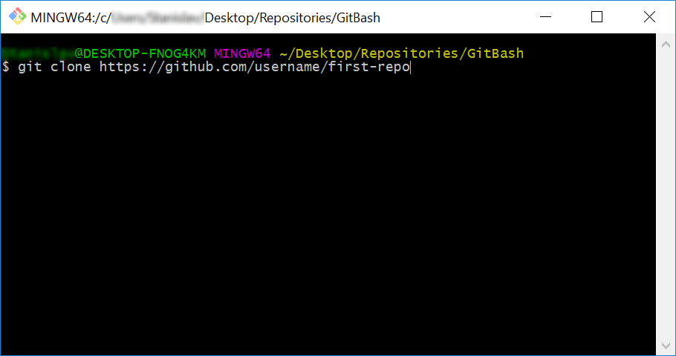

* The result should be something like this:

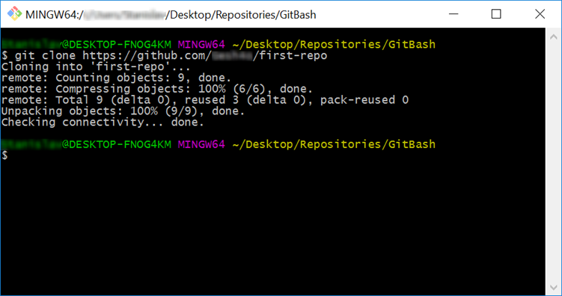

## Make a Conflict

Update content in both directories differently:

* On your **TortoiseGit** clone create "**test.txt**" file and add line: **"Creating with Tortoise…"**
* On your **GitBash** clone create "**test.txt**" file and add line: **"Creating with Bash…"**

## Upload Changes

Upload Your Changes from **TortoiseGit** Clone. You can use TortoiseGit's "**Git Commit…**":

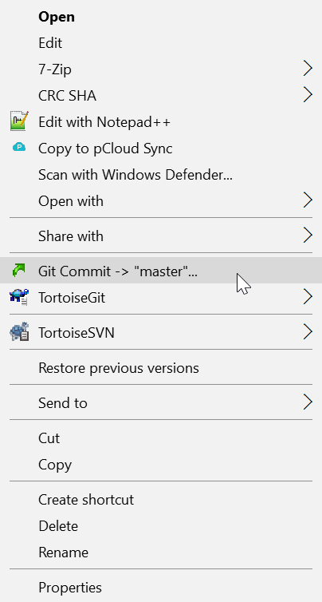 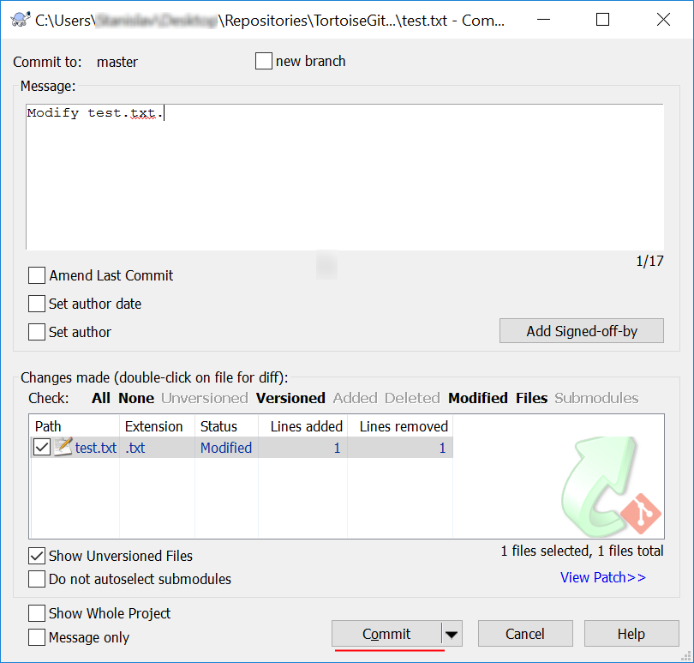

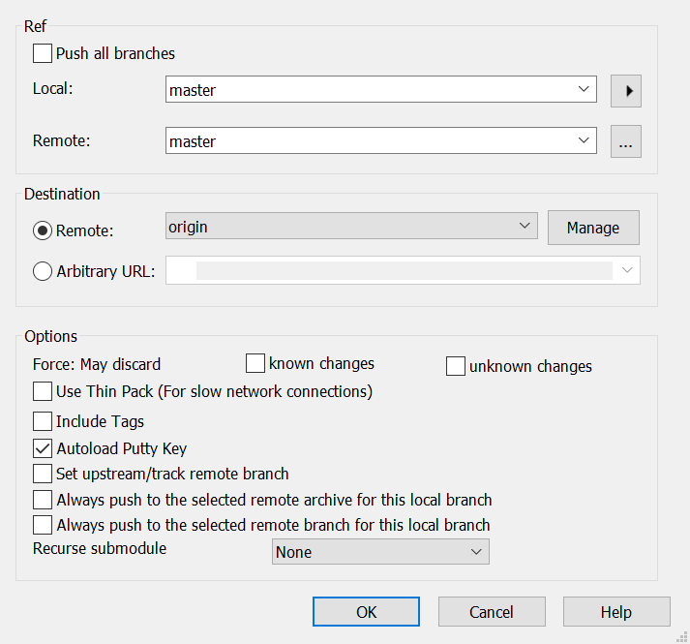

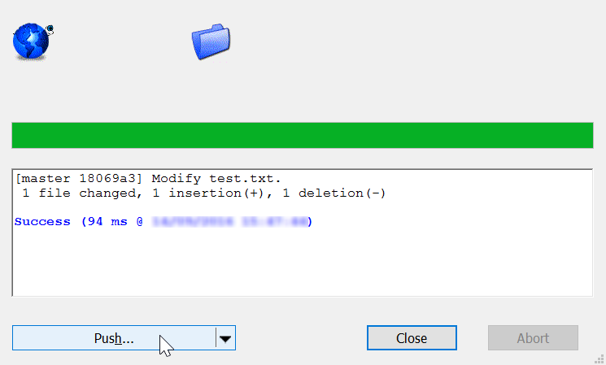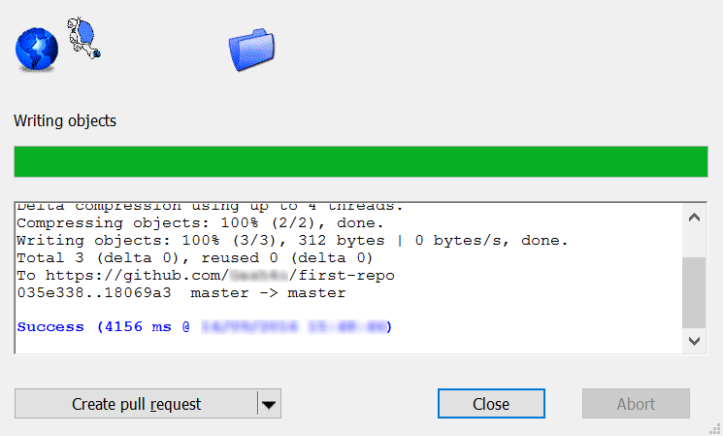

## Update Bash Clone

* Open your Git clone directory and open **GitBash** console. Run the following commands:
  + Add all modified files to **staging** area
    - "**git add .**"
  + **Commit** your changes and a give commit message.
    - **''git commit -m "Update test.txt."*"***
  + **Update** your local repository
    - "**git pull"**

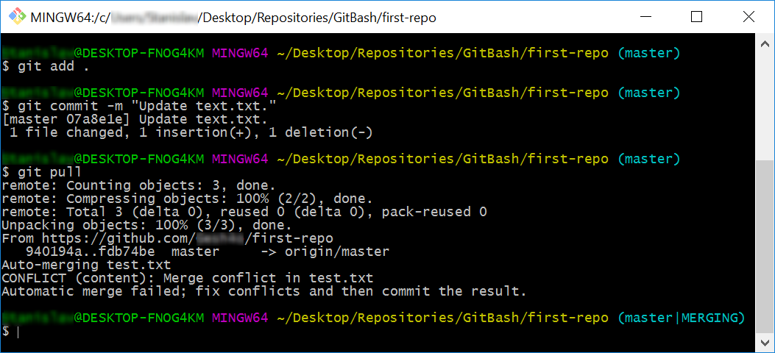

## Merge Conflict

Now you have merge conflict which you have to resolve

* + **Open** the **test.txt** file in your **GitBash** clone, it should look like this:

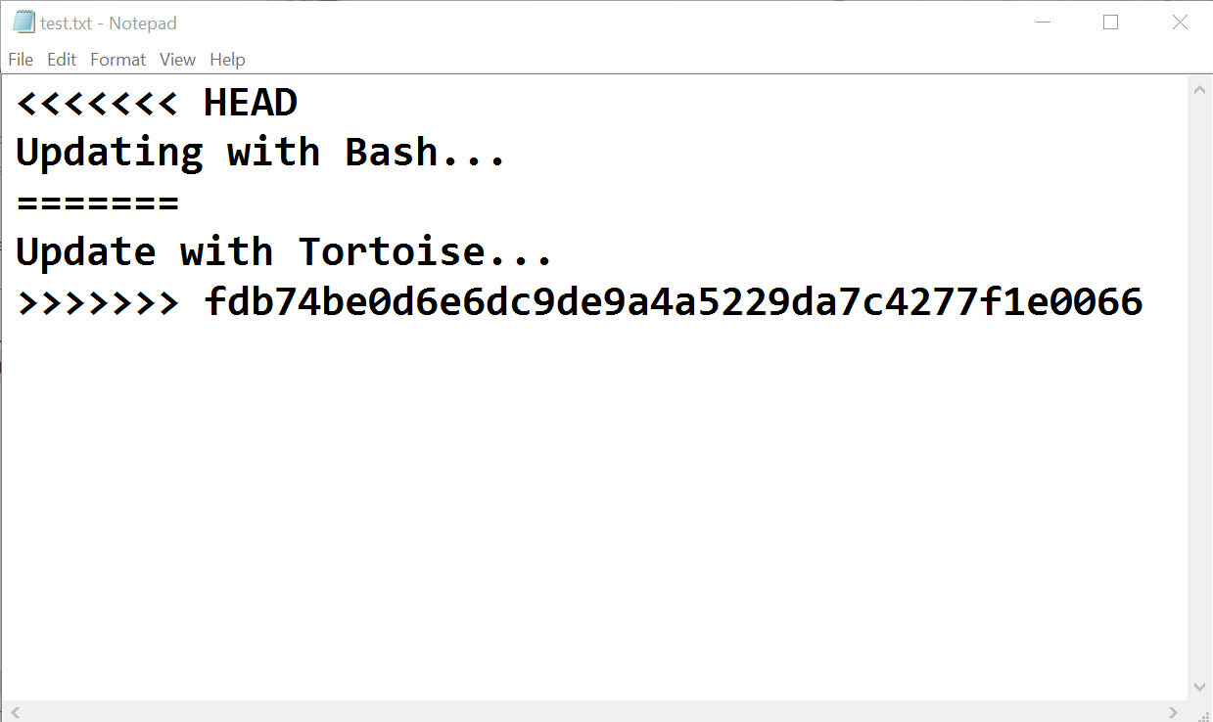

* + Remove the HEAD, ======, <<<<<<, >>>>>>> symbols and save the file.

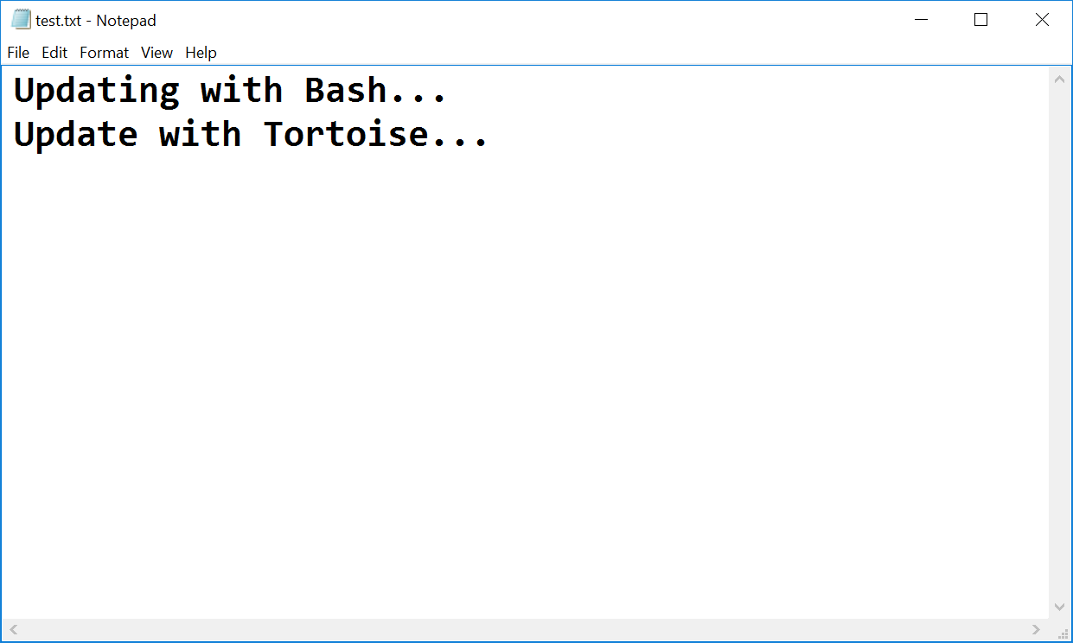

* Now that you have resolved the **conflict - stage** the modified file, **commit** again and   
  **sync** with the remote repository.

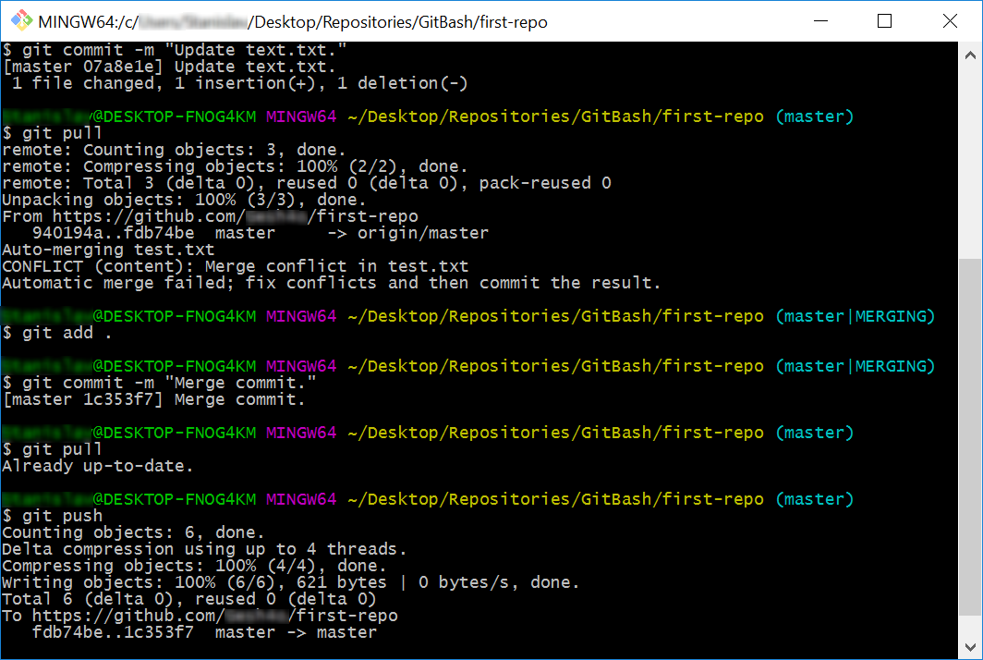

## Merge Changes and Push to GitHub

You have updated the content of your remote repository, now try to update your TortoiseGit clone

* Make additional changes to test.txt and **commit** them.

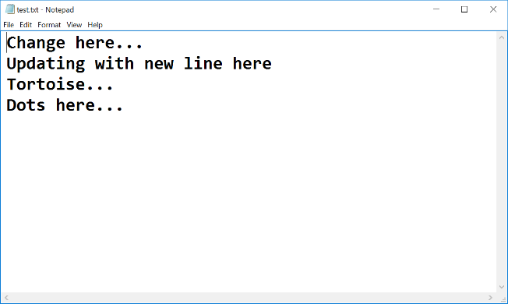

**\*Note** that if you make changes too simple TortoiseGit may **automatically** merge them.

* Now try to **push**. It turns out that we have our **remote** repository **updated** (the merge commit) and we do not have these changes on our **local** repository.

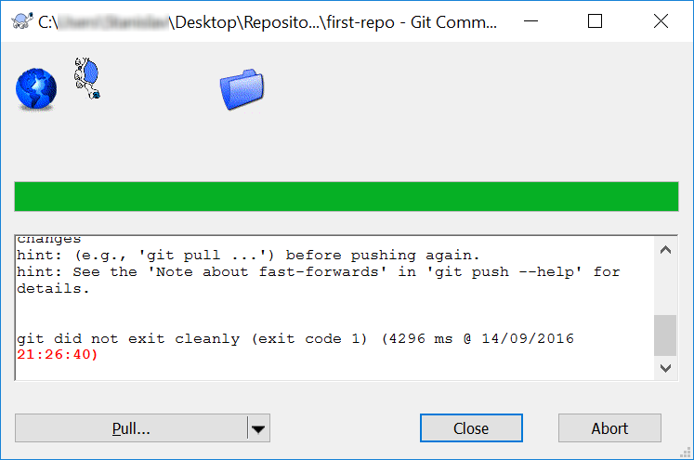

* So we have to **pull** new changes:

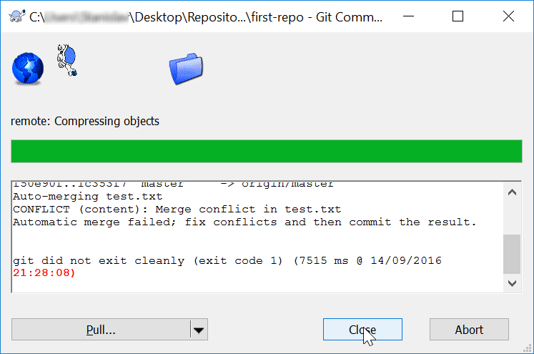

* Note that message: "Automatic merge failed; fix conflicts…". We have another conflict and we have to resolve it like we did earlier but small difference:
  + Go on the **test.txt** file. You should **open** the **file** and **remove** the same **symbols** that we have previously removed. Then right click on the file - choose **TortoiseGit** -> **Resolve…** and click it.   
    A dialog window should open. Then you click "**Ok**" in order to try to **resolve** the conflict.

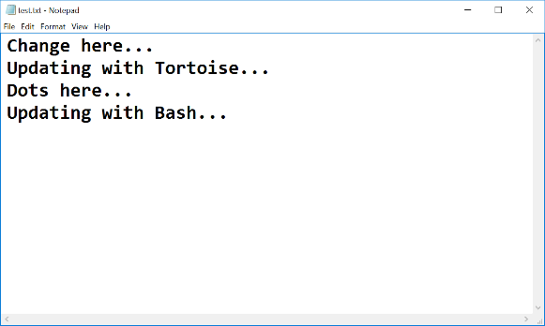

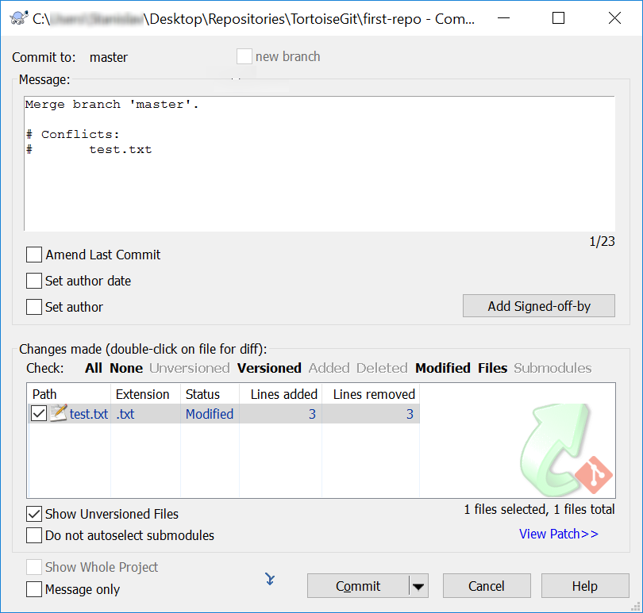

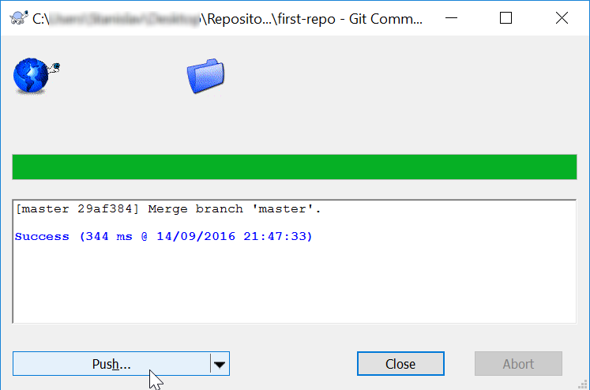

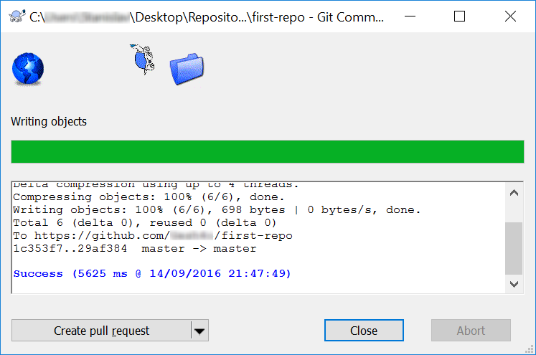

* Now our file is **clean** and we are ready for our final **commit**!

# Meet Your Colleagues

It’s time to meet a couple of **colleagues** at **SoftUni**. For this exercise, you must submit a **zip** file with all the solutions from the **problems below**.

## GitHub Profile Link

Create a new **text document**, called "1. GitHub Link.txt", and put a **link** to your **GitHub profile** inside it. The file should look something like this:

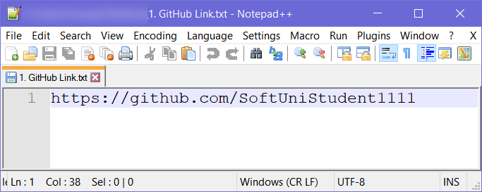

## GitHub Repository Screenshot

Take a **screenshot** of your **GitHub repository**, using something like [snipping tool](https://support.microsoft.com/en-us/help/13776/windows-use-snipping-tool-to-capture-screenshots), then save the file as   
"2. GitHub Repo.jpg".

## Meet Some Colleagues

First and foremost, look around the hall and try to **make acquaintances** with your fellow students. After you meet someone, **note down** the following information about them in a **text document**:

* What is their **name**?
* Where are they **from**?
* What **hobbies/pastimes** do they enjoy?
* Why did they pick **SoftUni**?

Try to do this with **at least 3** students and also exchange **contact information** with them.

Hopefully you made a couple new friends from this exercise. ☺

## Upload Homework to SoftUni

Put all of the text files and screenshots you created in a **zip file** and **send it as homework** on the **SoftUni** site.

# Teamwork

Work into **teams** of (about) 5 students in class

* Online students work alone or form own teams.
* Each team selects a "**team leader**".

The team leader **creates a repository** in GitHub e.g. "**test-repo**":

## Add a File to GitHub

Team members add a few files:

1. Clone the "**test-repo**" into your computer (if not cloned yet)
2. Create a new file into your working directory
   * Name the new file **"<your_name>.txt"**
   * Put some text in it the file, e.g. "*My name is …*"
3. Commit the **new file** to your **local repository**.
4. Sync the changes to **upload your file to the remote repo**.
5. Browse the repo from <https://github.com/user/repo> to check whether your file is successfully uploaded in GitHub.

## Create a Git Conflict & Merge

* All team members create a common file **"config.txt****"**
* Each team member adds some settings in **"config.txt"**, e.g.:
  + **name = Peter**
  + **size = 100**
  + **email = peter@dir.bg**
* Each team member **commits** his local changes.
* Each team member **syncs** his changes.
  + The first member will succeed without **conflicts**.
  + The others will have a **conflict** to be merged.
  + **Resolve** the conflict:
    - **Edit** the merged changes + **commit** and **sync** again.